

A Project

Report On

**Hotel Management System**

**By**

# Deepika c

# BCA

# Batch:2020-5355

**Center:Bangalore-TC/Palya**

Under the Guidance of,

**V. Jayanth**

**Technical Trainer**

**Edu Bridge**

(School of coding)

**Introduction:**

The project vydika Hospital Management system includes registration of patients, storing their details into the system. The software has the facility to give a unique id for every patient and stores the details of every patient and the staff automatically. It includes a search facility to know the current status of each room. User can search availability of a doctor and the details of a patient using the id.

The vydika Hospital Management System can be entered using a username and password. It is accessible either by an administrator or receptionist. Only they can add data into the database. The data can be retrieved easily. The interface is very user-friendly. The data are well protected for personal use and makes the data processing very fast.

The purpose of the project entitled as “vydika HOSPITAL MANAGEMENT SYSTEM” is to computerize the Front Office Management of Hospital to develop software which is user friendly, simple, fast, and cost – effective. It deals with the collection of patient’s information, diagnosis details, etc.

Traditionally, it was done manually. The main function of the system is to register and store patient details and doctor details and retrieve these details as and when required, and also to manipulate these details meaningfully System input contains patient details.

**Our Project Include Modules:**

* Admin Module
* Registration module
* Doctor Module
* Patient module
* Ambulance driver

I have developed this Application in **Java, JSP, Servlets, and MySQL.** It’s a web-based projects so I have used **HTML, CSS**.

**Admin:**

Hospital administrators are responsible for organizing and overseeing the health services and daily activities of a hospital or healthcare facility. They manage staff and budgets, communicate between departments, and ensure adequate patient care amongst other duties.

**Doctor:**

Doctor can view patient’s appointment and update their profile.

**Patient:**

Patient can take appointment for visiting doctor.

**SoftwareRequirements:**

**Front end:** Java/J2EE technologies (Servlet, JSP), HTML, CSS

**Backend**:MySQLworkbench 8.0.25

**Middleware/Server:** Apache Tomcat v7.0. IDE: Eclipse IDE for Java EEDevelopers

**Browser:** Best result on Google Chrome

**Operating System:**Window10.

# DataDictionary

CREATE DATABASE HOR;

USE Hospital;

**Department table:**

CREATE TABLE `department` (

`dept_id` int (11) NOT NULL auto_increment,

`dept_name` varchar(100) default NULL,

`dept_description` varchar(400) default NULL,

PRIMARY KEY (`dept_id`)

) ENGINE=InnoDB DEFAULT CHARSET=latin1;

**Appointment table:**

CREATE TABLE `appointment` (

`apid` int(11) NOT NULL auto_increment,

`name` varchar(50) NOT NULL,

`email` varchar(130) NOT NULL,

`contact` varchar(130) NOT NULL,

`age` int(11) NOT NULL,

`day` varchar(130) NOT NULL,

`speciality` varchar(130) NOT NULL,

`description` varchar(200) NOT NULL,

`id` int(11) NOT NULL,

PRIMARY KEY (`apid`)

) ENGINE=InnoDB DEFAULT CHARSET=latin1;

**Doctor Table:**

CREATE TABLE `doctor` (

`doctor_id` int(11) NOT NULL auto_increment,

`doc_name` varchar(100) default NULL,

`email` varchar(100) default NULL,

`password` varchar(100) default NULL,

`address` varchar(400) default NULL,

`phone` varchar(100) default NULL,

`department` varchar(100) default NULL,

PRIMARY KEY (`doctor_id`)

) ENGINE=InnoDB DEFAULT CHARSET=latin1;

**Feedback Table**

CREATE TABLE `feedback` (

`name` varchar(100) default NULL,

`email` varchar(100) default NULL,

`contact` varchar(200) default NULL,

`suggestion` varchar(400) default NULL

) ENGINE=InnoDB DEFAULT CHARSET=latin1;

**Nurse Table:**

CREATE TABLE `nurse` (

`nurse_id` int(11) NOT NULL auto_increment,

`name` varchar(45) default NULL,

`email` varchar(100) default NULL,

`password` varchar(100) default NULL,

`address` varchar(400) default NULL,

`phone` varchar(100) default NULL,

PRIMARY KEY (`nurse_id`)

) ENGINE=InnoDB DEFAULT CHARSET=latin1;

**Patient Table:**

CREATE TABLE `patient` (

`patient_id` int(11) NOT NULL auto_increment,

`patient_name` varchar(100) default NULL,

`email` varchar(100) default NULL,

`password` varchar(100) default NULL,

`address` varchar(400) default NULL,

`phone` varchar(100) default NULL,

`sex` varchar(45) default NULL,

`birthdate` varchar(100) default NULL,

`age` int(11) default NULL,

`blood_group` varchar(45) default NULL,

PRIMARY KEY (`patient_id`)

) ENGINE=InnoDB DEFAULT CHARSET=latin1;

**Admin Table**

CREATE TABLE `user` (

`user_id` int(11) NOT NULL auto_increment,

`name` varchar(100) default NULL,

`email` varchar(100) default NULL,

`address` varchar(400) default NULL,

`phone` varchar(200) default NULL,

`password` varchar(100) default NULL,

PRIMARY KEY (`user_id`)

) ENGINE=InnoDB DEFAULT CHARSET=latin1;

# Screenshots:-

**Home page:**

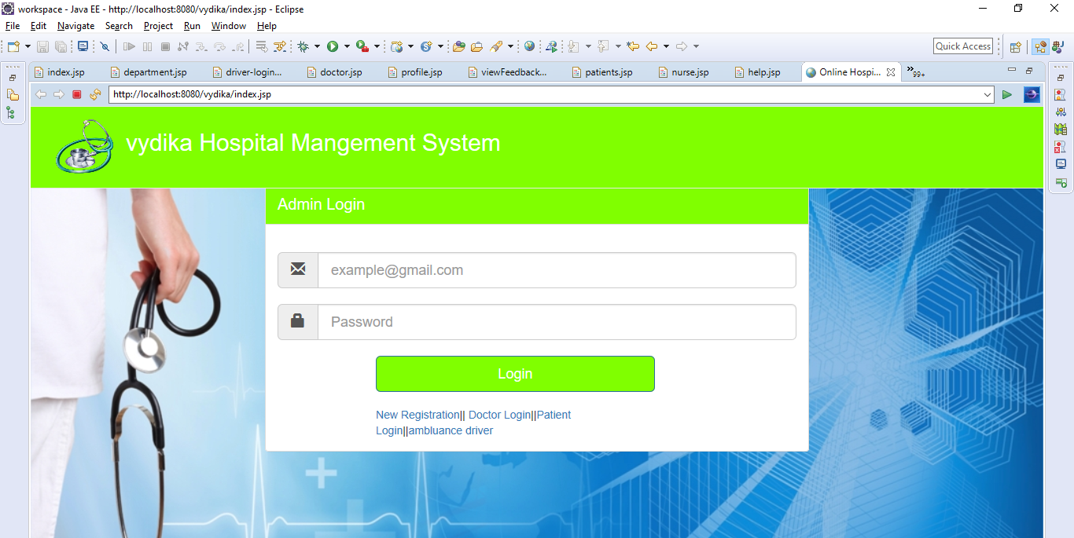

**Login With Admin Details:**

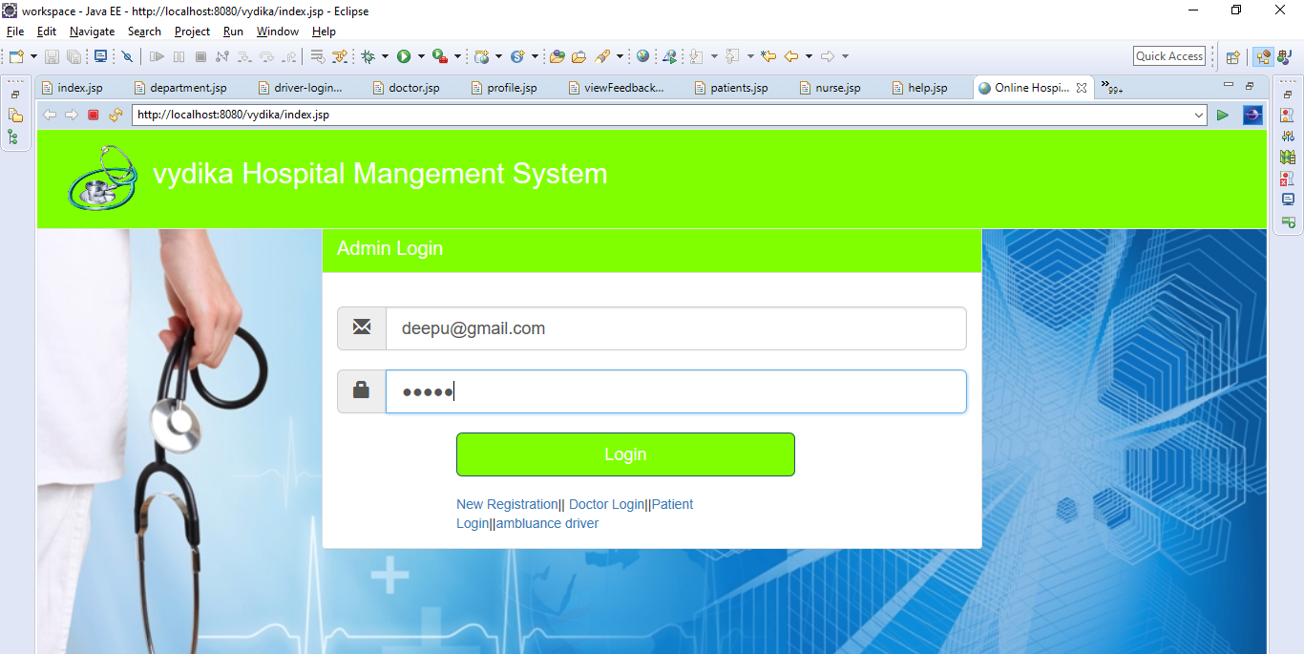

**Adim Department Page:**

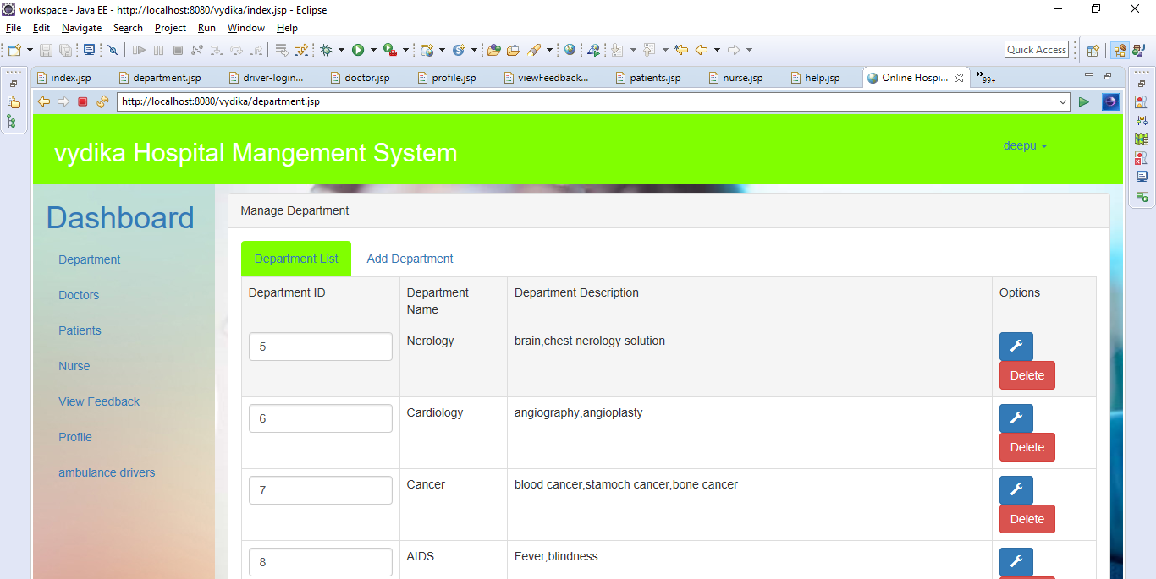

**Adim Regiter Page:**

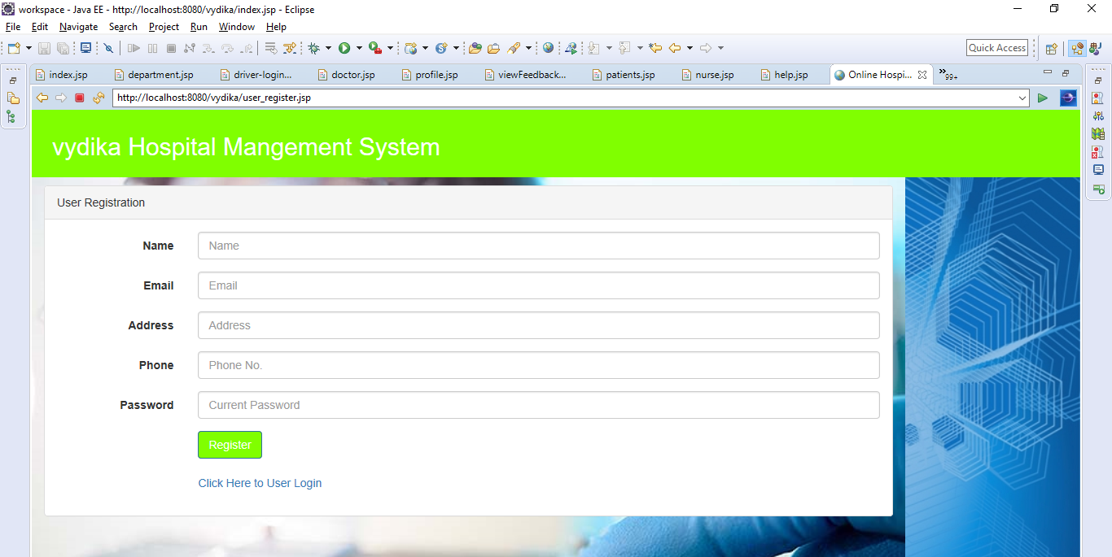

**Doctor login Page:**

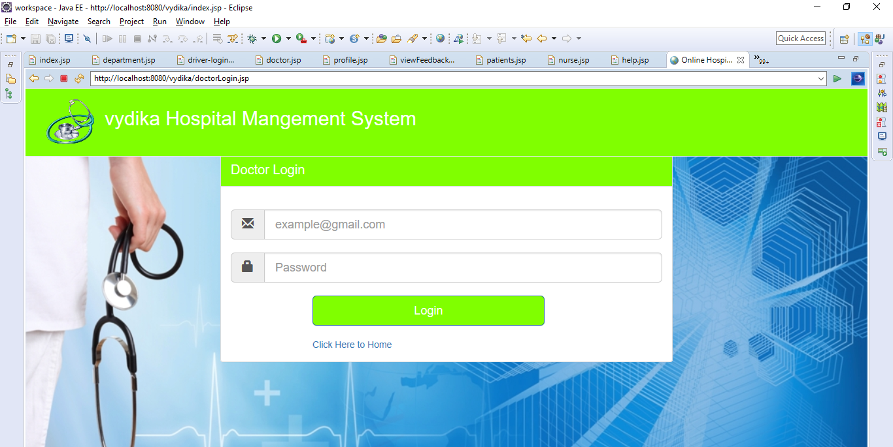

**After Doctor Login Page:**

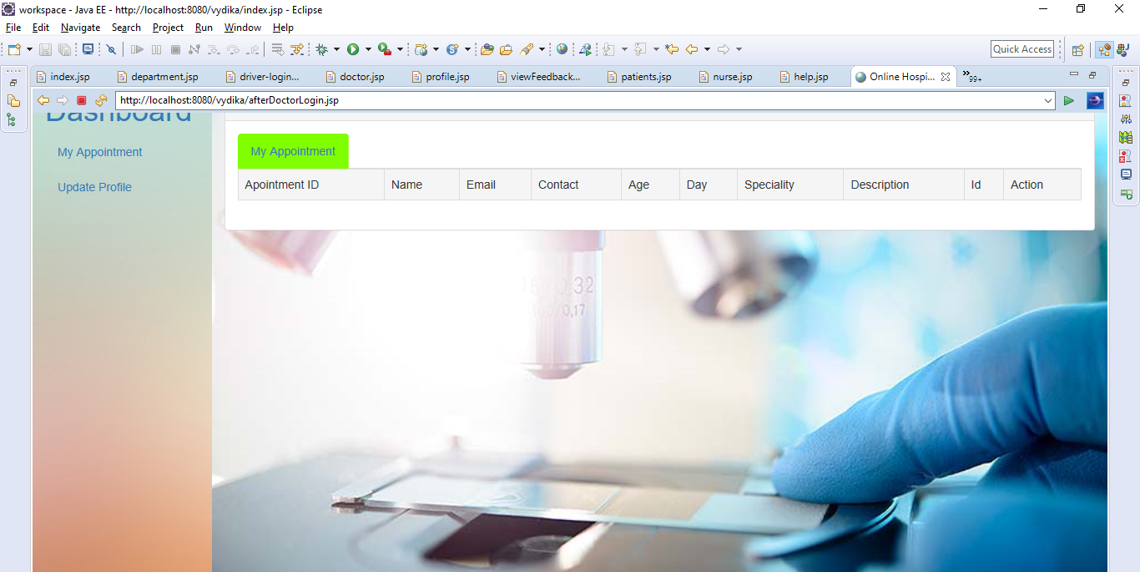

**Patient Login Page:**

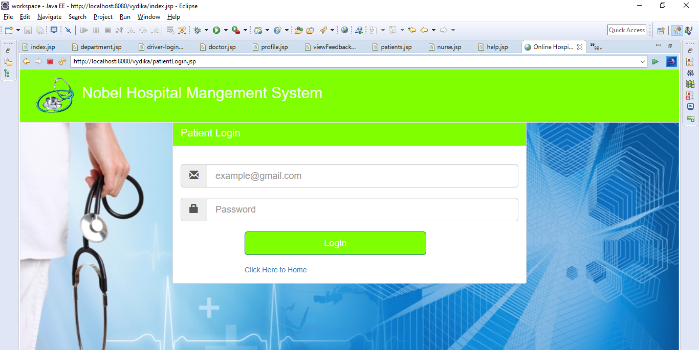

**After patient login Page:**

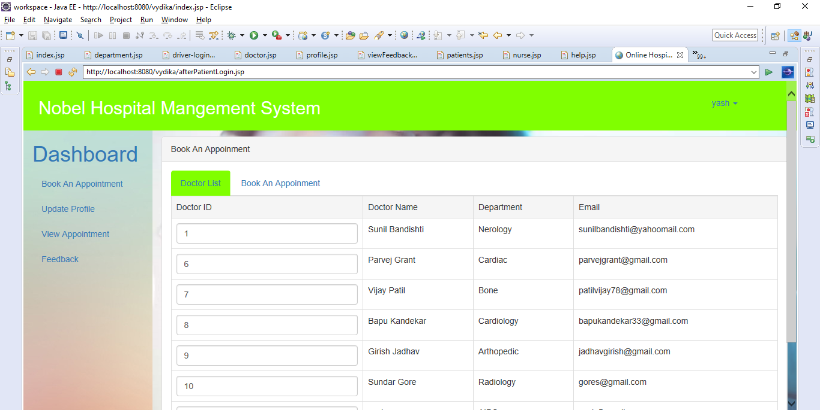

**Ambulance Driver Login page:**

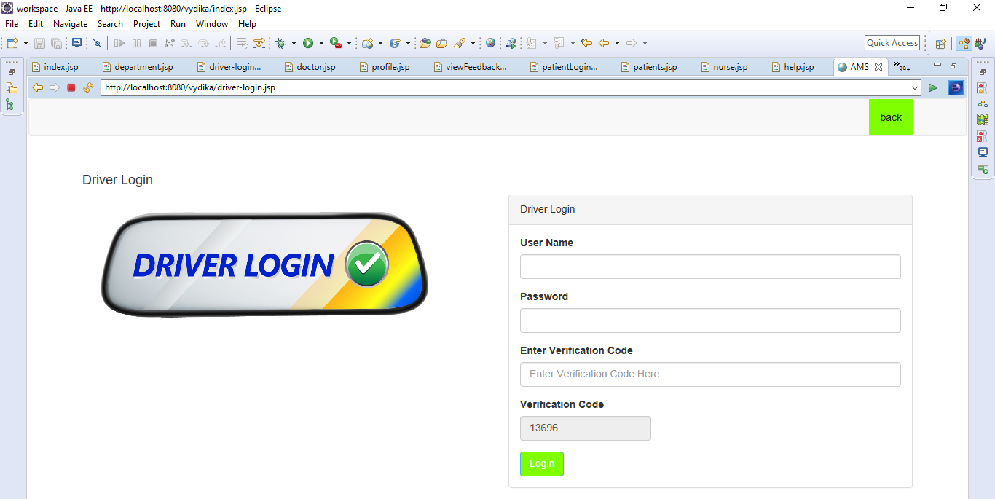

**After Driver Login Page:**

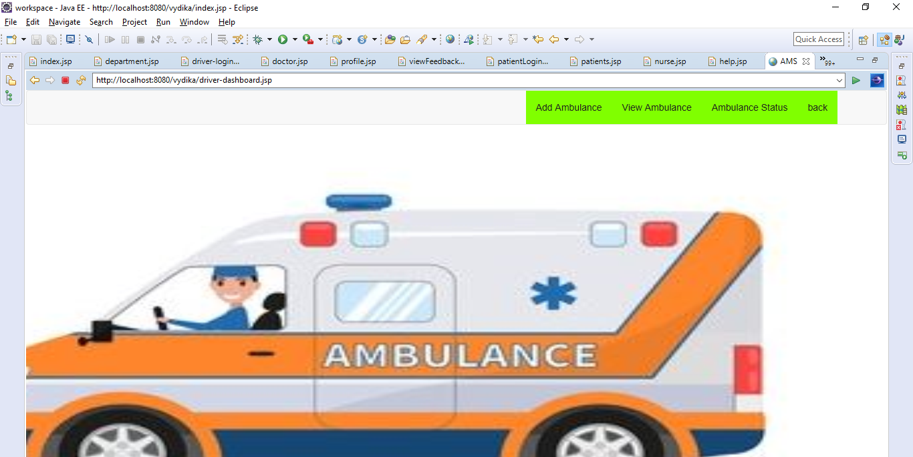

**Data Added in Database SuccessFully:**

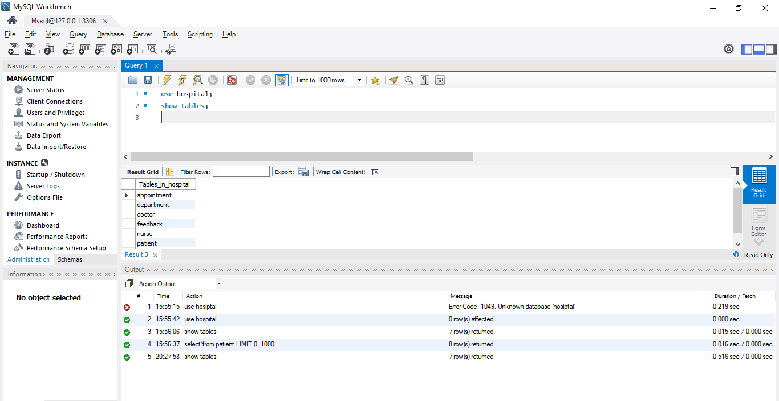

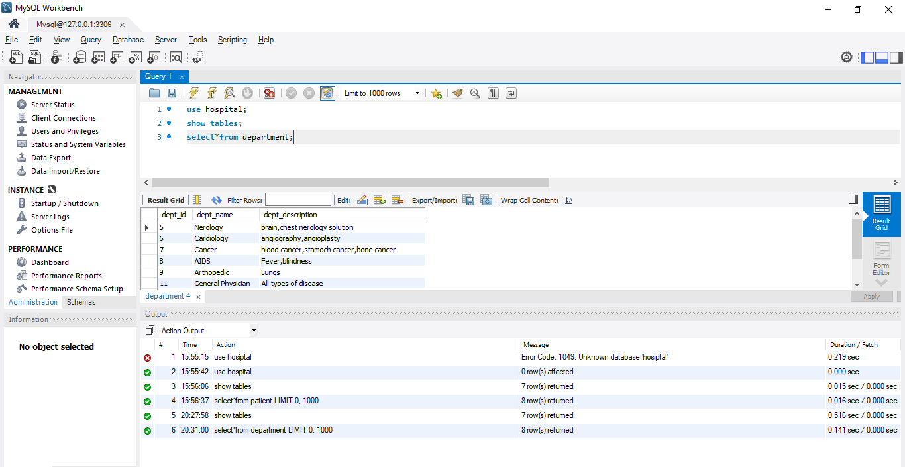

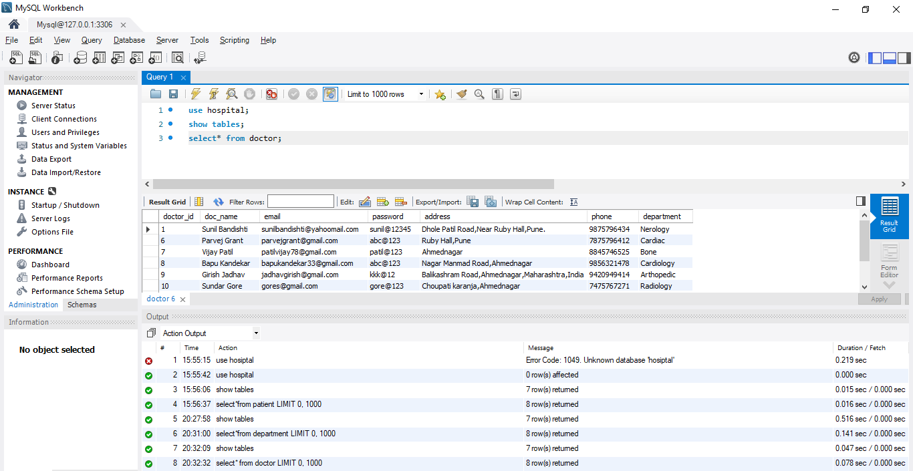

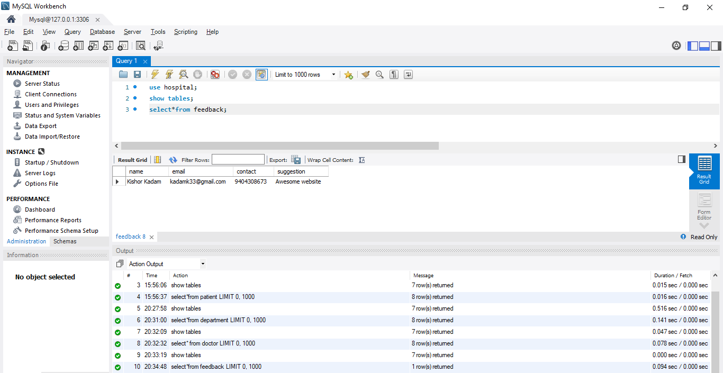

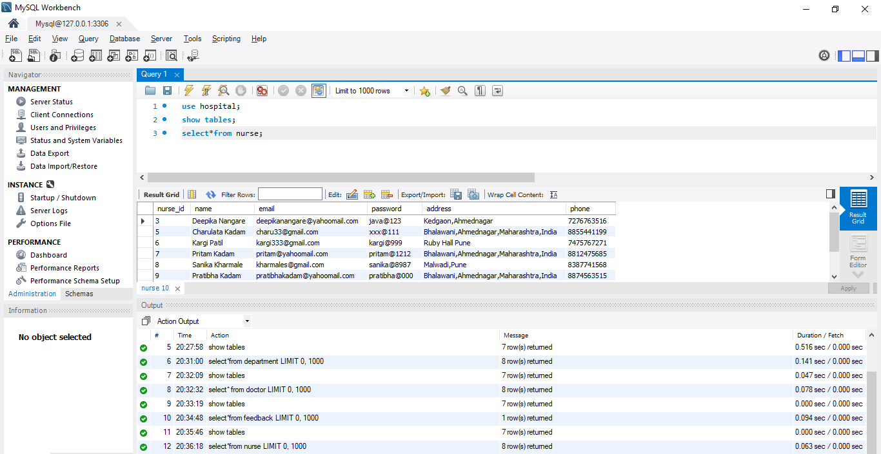

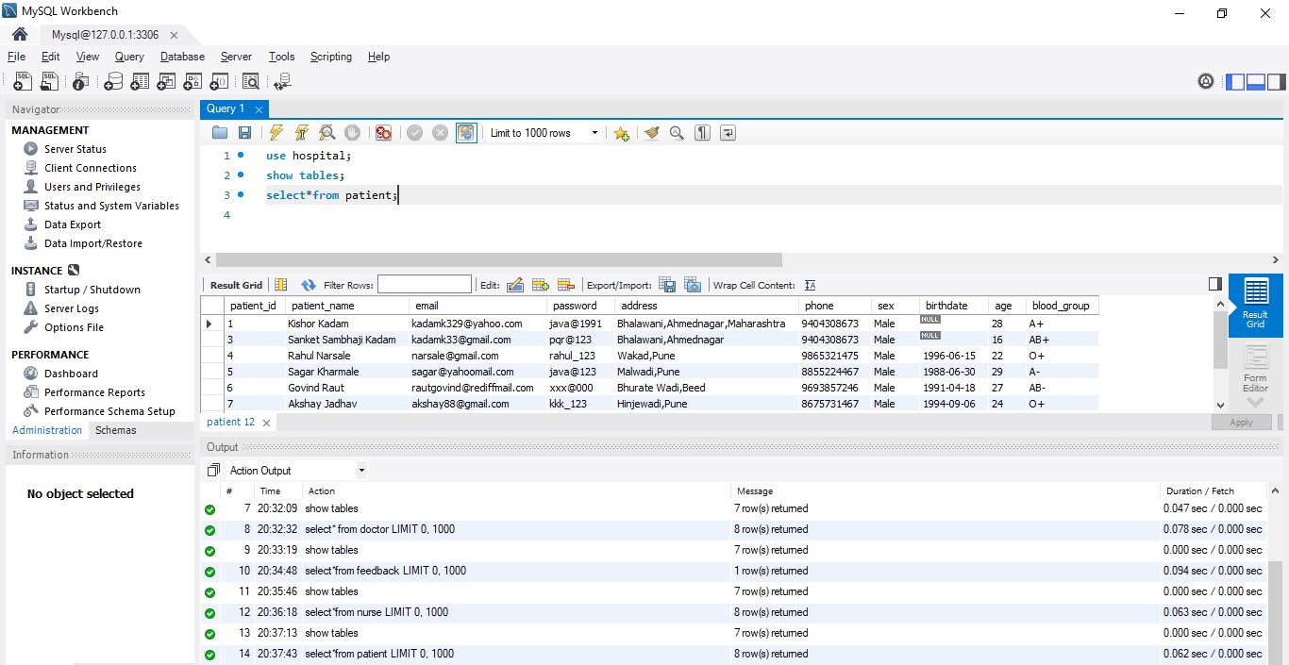

**Thank you**